Notice of Mariners 02/2024

Harbour Master

All mariners are advised from 1st April 2024 Gareth Thomas has been appointed as Harbour Master for Larne and Grant Laversuch appointed as Deputy Harbour Master.
Contact details are as follows;
Harbour Master Deputy Harbour Master
Gareth Thomas Grant Laversuch
Tel: +44(0)7866835839 +44(0)7714450895
Email: gareth.thomas@poferries.com grant.laversuch@poferries.com

This notice will self-cancel 1st June 2024 at 0900 UTC.

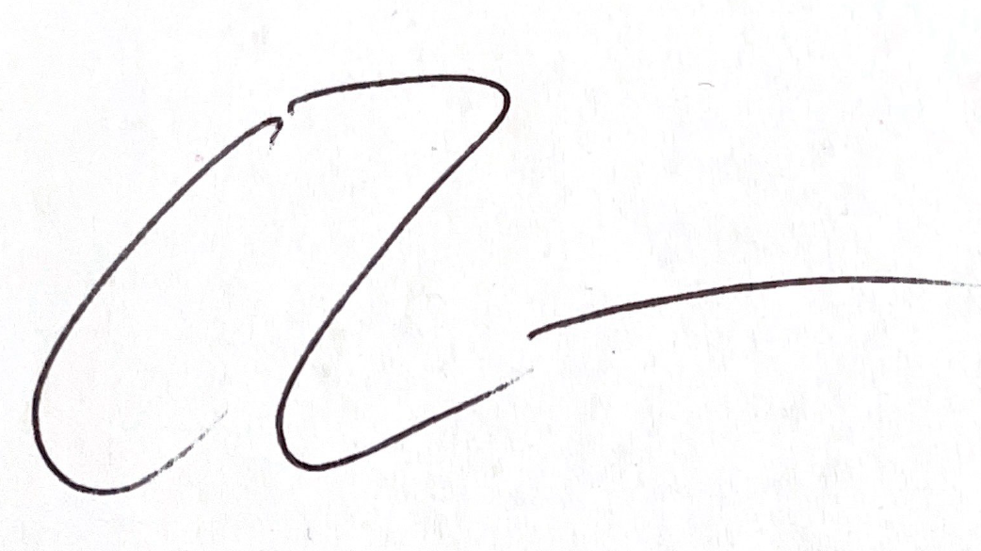
Gareth Thomas
Harbour Master
PORT OF CAIRNRYAN 03/04/2024

Notices still in effect
NtM 02 (2018) Notification of incidents
NtM 10 (2018) Anemometer at Cairnryan Ferry Terminal
NtM 02 (2019) Reporting requirements Port of Cairnryan
NtM 04 (2023) Berth Depths
NtM 01 (2024) Active Notices to Mariners

