Notice of Mariners 02/2024

Harbour Master

All mariners are advised from 1st April 2024 Gareth Thomas has been appointed as Harbour Master for Larne and Grant Laversuch appointed as Deputy Harbour Master.
Contact details are as follows;
Harbour Master Deputy Harbour Master
Gareth Thomas Grant Laversuch
Tel: +44(0)7866835839 +44(0)7714450895
Email: gareth.thomas@poferries.com grant.laversuch@poferries.com

This notice will self-cancel 1st June 2024 at 0900 UTC.

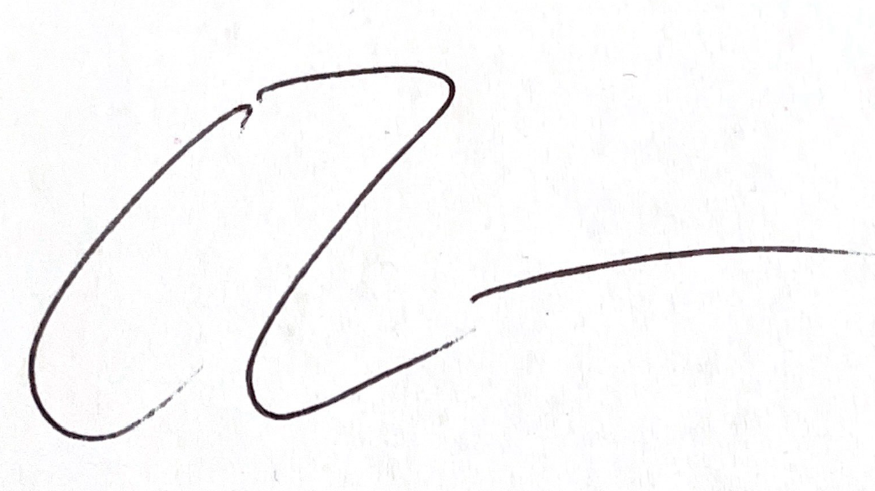
Gareth Thomas
Harbour Master
LARNE PORT 03/04/2024

Notices still in effect
NtM 03 (2010) Ship movement during bunkering.
NtM 01 (2017) Continental Quay.
NtM 09 (2017) Reporting of Accidents
NtM 02 (2019) Vessel Reporting Requirements.
NtM 12 (2020) Larne Port Web Site.
NtM 21 (2020) Bunkering Transferring Operations.
NtM 05 (2023) Olderfleet Rowing Club
NtM 06 (2023) Berth and Channel Depths.
NtM 07 (2023) Commercial Fishing Port Limits.
NtM 01 (2024) Active Notices to Mariners

